.GUIDELINE: WRITING ARTICLE FOR DOT.

GENERAL NOTES FOR THE WRITERS.
- Considering English as a foreign language and please try to keep the structure of the article simple and easily readable.
- Please use British English.
- In necessary cases use superscript for references and add references at the end of the article.
- TITLE and Sub Title should follow the prevailing standards.

1.0 PROJECT DESCRIPTION:
Project Background: Describe the brief history of the Project assigned.
Description of the assignment [Program] stipulated by the Clients for the Architect/s:

2.0 PROJECT ABSTRACT:
This part shall include the data base of the project and must help the readers to grasp the overall physical glances of the project.
2.1 Name of the Project:
2.2 Location:
2.3 Name of the Client:
2.4 Site Area:
2.5 Total built up area of the Project
2.6 Year of Commencement
2.7 Year of Completion
2.8 Project Cost in BD Taka
All measurements are to be in Square Meter.

3.0 PROJECT TEAM:
Please mention the name of the designers in this section in tabular format
Principal Architect
3.1 Architect[s]
3.2 Consultant[s]:
Architecture:
Structure:
Mechanical:
Electrical:
Interior Design:
Landscape Design:
Any other[s]:

4.0 CONCEPT
This segment shall elaborate the Spatial Translation of the Client in Brief considering the context and any other issues that architect felt worth addressing in the design. This part of the article may include the development and or the Metamorphosis of the design process along with sketches.
5.0 ARCHITECTURE
This segment should include elaborate description of the building itself considering the functional distributions. Focus also should be paid on the significance of the Project based on the following:
5.1 Location Potential
5.2 Site Selection
5.3 Building Orientation
5.4 Minimum Habitat Disturbance
5.5 Protection and Conservation of Natural Resources and Ecologically Sensitive Areas
5.5 Enhancement of Environment Quality

6.0 PROJECT TECHNOLOGY
This Part, if the writer finds it befitting, may include the description of the special Construction Technology/Structural System adopted in the design and in the construction. This may include the challenges in structural aspects and in construction as well.
Unless the project imparts a special and extra ordinary technology, the writer may skip this segment.
7.0 MATERIALS
This segment shall describe a general overview of the materials used for the project. Describe and indicate whether locally produced or imported materials are being used for the project or any special material used that gives the project a unique character. This may cover both the Architecture and Interior of the Project.

8.0 PROJECT SERVICES
Describe the Site Utilities and building services that have been considered during the design process and also indicate whether the project is imparting any negative impact on the surrounding. This segment shall require a critical standing of the writer being unbiased.

Protection and Conservation of Natural Resources and Ecologically Sensitive Areas are needed to be addressed if they are at all addressed in the project. Otherwise the writer may skip this second segment.

9.0 CONSTRAINTS AND SOLUTIONS ACHIEVED
The writer shall include the Constraints inherent in the project and Solutions achieved by the Architect for the project.
10.0 SPECIAL FEATURES
The writer may include special feature that may be considered as a unique case.
11.0 DETAILS OF SUPPORTING STRUCTURES
Describe Ancillary Facilities / Parking / Access / Circulation etc. in applicable projects.

12.0 DETAILS OF LANDSCAPING
The writer in applicable projects may highlight the landscaping features.

13.0 IMAGES
13.1 The Image file in JPG/PNG/TIFF/BMP formats is to be attached
13.2 Each Image must have a unique ID: e.g. GP01

13.3 The attached soft copy must be accompanied with a matrix as shown below:
Sl. | Image ID/File name | Caption | Photographer
01 | e.g. GPH 01.jpg | e.g. The East and West Wings are placed aligning the site lines hence juxtaposing with each other and giving an expression of being created for the society.
…n

13.4 Resolution: At least 300 dpi
Size: maximum 2480 pixels by 8700 pixels
Mode: Photography: CMYK Drawings: Grayscale

13.5 Images must have the name of the Photographer/s

13.5 All images must be copyrighted by the Writer or must have written permission for using them in the article.

14.0 DRAWINGS
14.1 The Drawings rendering must be simple. No Working Drawings with detail measurements and hatches are to be incorporated. The Drawings shall be more of a Presentation Style either Coloured or Black and White.

14.2 All Drawings must have
Photographic Scale
North Sign
Legend

14.3 Format: Vector PDF/CDR/AI/DWG/EPS/PNG

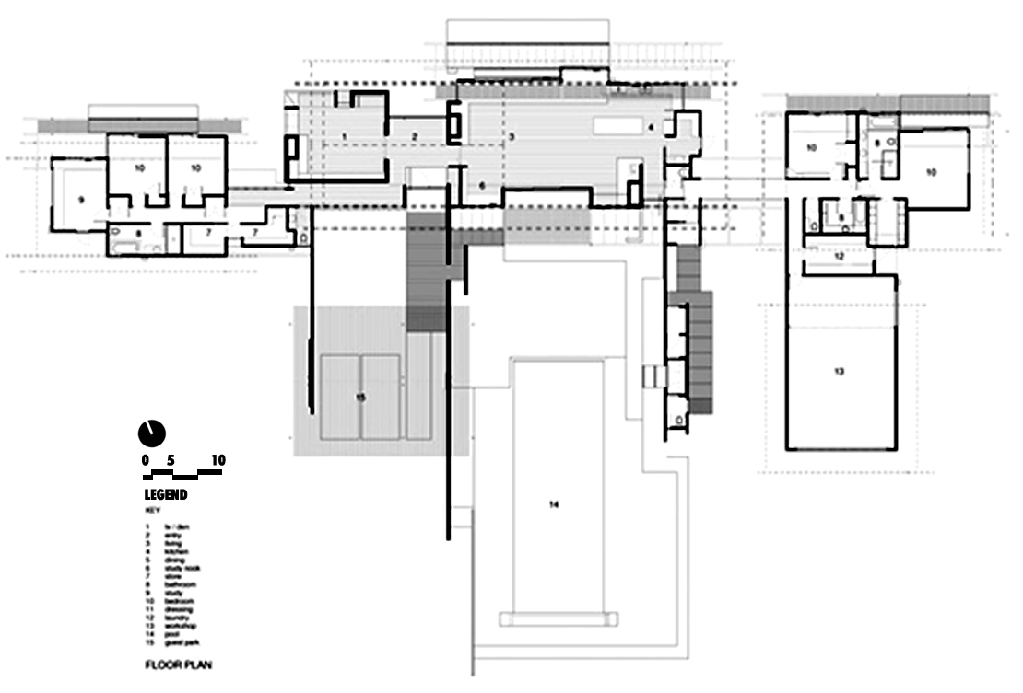
14.4 Sample: Solid Fill Walls with numbered Legend

